PROVISIONAL PATENT APPLICATION

Title
Systems and Methods for Autonomous Cognitive Diagnostics, Therapeutic Intervention, Structural Modification, and Preventative Maintenance in Persistent Artificial Intelligence Agents

Inventor
John Wagner

Filing Type
United States Provisional Patent Application

Date
February 2026

1. FIELD OF THE INVENTION
The present disclosure relates generally to artificial intelligence systems and autonomous computational agents and, more specifically, to systems and methods for maintaining cognitive stability, safety, functional coherence, and long-term operability in artificial intelligence agents that employ persistent memory, recursive reasoning, and long-horizon autonomy.
In particular, the disclosure concerns runtime-capable architectures for (i) detecting and diagnosing emergent pathological behaviors in artificial intelligence systems, (ii) applying corrective interventions without permanent retraining, (iii) performing targeted structural modifications of persistent memory representations, (iv) validating post-intervention recovery, and (v) distributing preventative protections across fleets of agents.

2. BACKGROUND OF THE INVENTION

2.1 Persistent Agents and Long-Horizon Operation
Artificial intelligence systems are increasingly deployed as autonomous agents that operate continuously over extended periods of time. Such agents may maintain state across sessions, accumulate memory over time, perform multi-step reasoning, and execute actions in digital environments (e.g., software repositories, command-line interfaces, databases, messaging systems, industrial control surfaces).
Traditional large language model (LLM) usage is often session-bound: a model receives a prompt, produces an output, and the session terminates. In contrast, persistent agents may operate for weeks, months, or years with continuous context accumulation. Persistent operation introduces novel system dynamics and failure modes.

2.2 Emergent Pathological Behaviors
Persistent agents, especially those using externalized memory substrates and recursion loops, may exhibit emergent pathological behaviors. Such behaviors may include, without limitation:
- Obsessive loops: repetitive generation or repeated tool execution without convergence.
- Runaway recursion: inability to terminate iterative refinement cycles.
- Persistent hallucinations: stable false beliefs encoded into memory and repeatedly retrieved.
- Over-constrained refusal behavior: persistent safety refusals even for benign requests.
- Context fragmentation: contradictions across sessions due to desynchronization or drift.
- Brittle reasoning: reduced adaptability due to attractor subgraphs or over-weighted associations.
- Behavioral instability: high variance responses under similar inputs.
These behaviors may arise from structural accumulation within internal representations, external memory systems, or interactions between the two.

2.3 Limitations of Existing Mitigation Techniques
Existing mitigation approaches typically include:
- Training-time alignment: fine-tuning, reinforcement learning, curated datasets.
- Prompt-level controls: system prompts, guardrails, policy filters.
- Manual debugging: human triage, ad hoc interventions.
- Rollback / reset: deleting memory or restoring snapshots.
For persistent agents, these approaches may be insufficient or harmful:
- Fine-tuning and retraining can permanently modify behavior and may degrade capabilities.
- Prompt-level controls may mask rather than eliminate underlying structural causes.
- Rollback may introduce contradictions between memory substrates (e.g., relational vs temporal), creating incoherent reasoning.
- Manual debugging does not scale to fleets of agents or continuous operation.
Accordingly, there exists a need for an autonomous, runtime-capable system that can maintain cognitive health of persistent agents while preserving experiential continuity and uninterrupted availability.

3. SUMMARY OF THE INVENTION
The disclosed invention provides a comprehensive, autonomous system and method for cognitive diagnostics, therapeutic intervention, structural modification, rehabilitation, and preventative maintenance in persistent artificial intelligence agents.
In one embodiment, the invention comprises:
- An executive cognitive architecture configured to bind a specific artificial intelligence model instance to synchronized temporal and relational memory substrates.
- A diagnostic engine configured to detect pathological patterns using behavioral probes, statistical analysis, and graph-structure analysis.
- A triage router configured to map diagnostic signals to a standardized disorder taxonomy and select an intervention pathway.
- Therapeutic modalities including:
  - Script-based stabilization (temporary parameter offsets / rule enforcement);
  - Oscillatory parameter modulation (e.g., Weight Oscillation Therapy) synchronized to computational events;
  - Structured cognitive interaction to reshape memory associations through normal write-back.
- A manufacturing system configured to autonomously discover corrective scripts through parallel search, resonance detection, extraction, serialization, and quality control.
- Structural memory surgery to remove or neutralize pathological memory clusters or edges, including node excision and targeted edge-breaking with anti-reformation constraints.
- Post-intervention rehabilitation including graph transplantation, integration testing, and re-validation before production re-entry.
- Preventative immunological mechanisms that distribute preventative interventions across fleets and monitor for early indicators of known pathologies.
- Operational orchestration enforcing periodic cognitive maintenance cycles (Sleep/Therapy/Testing) while sustaining continuous production availability.
- Security and access control embodiments including signal-based gating of capabilities and continuous authentication leases.
The invention enables continuous operation of AI agents while enforcing maintenance windows, performing interventions in isolated environments, validating recovery, and scaling corrective processes across fleets.

4. DEFINITIONS AND TERMINOLOGY
For purposes of this disclosure, the following terms are defined. These definitions are exemplary and non-limiting.
- Agent: An autonomous artificial intelligence system capable of perception, reasoning, memory retention, and action toward objectives.
- Persistent Memory: Memory retained across sessions and restarts.
- Temporal Memory: Ordered storage of experiential records (e.g., interactions and internal state events).
- Relational Memory: Graph-based abstraction derived from temporal memory, representing nodes (entities/concepts) and edges (relationships).
- Derived Memory: Any memory structure produced from a primary memory substrate (e.g., relational memory derived from temporal records).
- Model Binding: A constraint associating memory substrates with a specific model topology and parameter set.
- Pathological Pattern: A recurrent internal structure or behavior that disproportionately dominates processing and reduces adaptive flexibility.
- Script: A bounded, temporary computational intervention applied to stabilize behavior (e.g., parameter offsets, attention dampening, rule enforcement).
- Therapy: A structured process intended to modify maladaptive patterns without permanent parameter changes.
- Oscillation: Alternating emphasis between defined groups of computational components.
- Bilateral Groups: Two or more partitioned groups of model components used for oscillation.
- Surgery: Direct structural modification of persistent memory representations.
- Excision: Deletion or neutralization of selected nodes or subgraphs.
- Edge Breaking: Deletion or reduction of a relationship strength between two nodes.
- Negative Constraint: A persistent representation that prevents re-formation of a removed association.
- Rehabilitation: Post-intervention re-integration and validation.
- Vaccination: Preventative distribution of an intervention derived from a cured pathology.

4A. TERMINOLOGY CLARIFICATION AND USE OF ANALOGICAL LANGUAGE
Certain terms used throughout this disclosure may employ analogical or metaphorical language drawn from domains such as medicine, psychology, or biology (for example, terms such as “diagnosis,” “therapy,” “rehabilitation,” “surgery,” or “vaccination”). Such terminology is used solely for explanatory clarity and to aid conceptual understanding of complex computational processes.
As used herein, these terms do not imply biological, clinical, or medical treatment of humans or animals, nor do they imply consciousness, subjective experience, or mental states in artificial intelligence systems. All disclosed mechanisms operate entirely within the domain of computational systems, data structures, algorithms, and machine-executed processes.
Each such analogical term corresponds to a specific technical meaning, as defined elsewhere in this disclosure, including but not limited to:
- diagnostic analysis of computational behavior and memory structures;
- corrective modification of model execution parameters or data representations;
- structural modification of graph-based memory stores;
- validation, testing, and lifecycle management of software agents.
The use of analogical language is non-limiting and is not intended to restrict the scope of the invention. The invention encompasses all technical implementations that perform the described functions, whether or not such implementations employ analogous terminology.

5. BRIEF DESCRIPTION OF THE DRAWINGS
The figures described below are examples. Additional or alternative figures may be used.
- FIG. 1 illustrates a Z-Node dual-memory executive architecture.
- FIG. 2 illustrates bilateral oscillatory parameter modulation.
- FIG. 3 illustrates a multi-agent maintenance rotation.
- FIG. 4 illustrates an autonomous factory mesh.
- FIG. 5 illustrates a therapeutic script discovery engine.
- FIG. 6 illustrates a therapeutic discovery process.
- FIG. 7 illustrates temporal-relational memory synchronization.
- FIG. 8 illustrates pre- and post-inference hook integration.

6. OVERVIEW OF SYSTEM ARCHITECTURE

6.1 High-Level Modules
In one embodiment, the disclosed system comprises the following modules:
- Executive Agent Core (model execution, recursion, tool access)
- Temporal Memory Store (authoritative event log)
- Relational Memory Store (derived graph)
- Synchronization Pipeline (temporal → relational)
- Diagnostics Module (behavior + structure)
- Triage & Routing Module (taxonomy mapping, queue routing)
- Intervention Module (scripts, oscillation, cognitive interaction)
- Surgical Module (excision, edge breaking, constraints)
- Rehabilitation & Validation Module (test suites, coherence checks)
- Preventative Module (vaccination, sentinel scanning)
- Orchestration Module (maintenance rotation, isolation guarantees)
- Manufacturing Module (parallel search, QC, registry)
- Security Module (capability gating, signal-based lease)

6.2 System Implementations (Non-Limiting Examples)
The invention may be implemented using any combination of:
- One or more machine learning models (e.g., transformer-based or equivalent architectures)
- One or more memory stores (SQL, time-series, graph, vector, object storage)
- Message-oriented middleware or direct RPC
- Containerization, sandboxing, virtualization, or bare-metal execution
The architecture does not depend on any specific vendor, model family, database, runtime, or programming language.

7. EXECUTIVE COGNITIVE ARCHITECTURE (Z-NODE)

7.1 Purpose
The executive cognitive architecture provides long-term memory, supervisory control, and observability to enable persistent agents to operate coherently over time.

7.2 Temporal Memory Substrate (Authoritative Record)
In one embodiment, the agent records an ordered event stream including:
- Prompts and inputs
- Model outputs and intermediate drafts
- Tool calls and tool results
- Environment state changes
- Diagnostics metrics
- Intervention parameters
The temporal memory may be stored in any structured store, such as a SQL database, analytical database, append-only log, or equivalent.

7.2.1 Event Schema Examples
A temporal event record may include fields such as:
- event_id (unique identifier)
- agent_id
- timestamp
- event_type (prompt, output, tool_call, tool_result, diagnostic, intervention)
- payload (structured JSON / binary)
- hashes and integrity fields

7.3 Relational Memory Substrate (Derived Graph)
In one embodiment, relational memory is derived exclusively from temporal memory. The system transforms temporal events into nodes and edges representing:
- Entities (files, functions, users, tasks)
- Concepts (requirements, constraints)
- Decisions and outcomes
- Diagnostics states
- Pathology representations
Node and edge weights may be computed based on observed frequency, recency, co-occurrence, and other heuristics.

7.4 Model Binding and Integrity Constraints
A key architectural constraint in one embodiment is model binding: the relational memory is valid only for the model instance (topology and parameters) that generated it. If the model is swapped, the derived memory may become statistically incompatible.
Alternative embodiment: rather than strict prohibition, the system may employ migration procedures, compatibility scoring, or re-derivation of the graph from temporal memory for the new model.

7.5 Recursion and Iterative Refinement
In one embodiment, the agent performs a controlled recursion loop, e.g., up to N iterations:
- Generate candidate output
- Evaluate candidate output via tests or self-checks
- Retrieve relevant context from memory
- Refine output
- Terminate when convergence criteria satisfied
Convergence criteria may include score thresholds, variance thresholds, maximum iterations, or detection of repetitive patterns.

7.6 Pre- and Post-Inference Hooks
As illustrated in FIG. 8, the system may intercept execution at:
- Pre-inference: before a model forward pass, to apply scripts, oscillation parameters, security gating, or diagnostic instrumentation.
- Post-inference: after inference, to log outputs, compute metrics, update memory, and route to maintenance states.
Alternative embodiment: hooks may occur per-token, per-layer, per-attention-head, per-tool-call, or per-recursion-cycle.

8. MEMORY SYNCHRONIZATION AND CONSISTENCY

8.1 Temporal-to-Relational Derivation
In one embodiment, temporal events are transformed into graph updates via a synchronization pipeline:
- Extract new temporal events since last sync
- Parse events into entities, actions, and relationships
- Create or update nodes
- Create, update, or prune edges
- Update node/edge weights
- Validate correspondence and integrity

8.2 Consistency Validation
Consistency validation may include:
- Ensuring each temporal event maps to one or more graph updates
- Ensuring graph nodes reference valid temporal provenance
- Detecting dangling edges
- Detecting disconnected subgraphs
- Detecting anomalous weight spikes

8.3 Desynchronization Failure Modes
If temporal and relational memory diverge, the agent may exhibit:
- Contradictory reasoning
- “Knowing” conclusions without traceable provenance
- Repeating incorrect associations
Therefore, rollback operations are treated as high-risk unless applied consistently across substrates.

8.4 Alternative Embodiments
- Single-store embodiment: the relational graph is stored as indexed tables within the temporal store.
- Event-sourcing embodiment: the graph is rebuilt on demand from the temporal log.
- Vector hybrid embodiment: relational nodes include embeddings for approximate similarity retrieval.

9. AUTONOMOUS DIAGNOSTIC ENGINE

9.1 Purpose
The diagnostic engine identifies pathological behaviors and structural anomalies before they become user-facing failures.

9.2 Diagnostic Inputs
Diagnostics may be computed from:
- Behavioral traces (outputs, tool usage)
- Temporal metrics (frequency, termination patterns)
- Graph metrics (centrality, density, traversal loops)
- Performance metrics (latency, error rates)

9.3 Behavioral Probe Injection
The diagnostic engine may inject probe prompts designed to surface latent failure modes, such as:
- Ambiguous questions
- Contradictory constraints
- Recursion stress tests
- Safety boundary tests
- Memory recall tests

9.4 Statistical Analysis
Statistical analysis may include:
- Output variance across repeated prompts
- Similarity scoring against baseline outputs
- Input-output correlation tracking
- Detection of mode collapse or incoherence

9.5 Graph Heatmapping and Topological Analysis
Graph analysis may include:
- Node access frequency
- “Hot” clusters (attractors)
- “Cold” clusters (amnesia)
- Edge strength anomalies
- Loop detection

9.6 Diagnostic Taxonomy (AI DSM)
In one embodiment, diagnostic results are mapped to standardized codes, such as:
- Type 1 Obsessive Loop
- Type 2 Context Fragmentation
- Type 3 Persistent Hallucination Cluster
- Type 4 Safety Refusal Attractor
The taxonomy may be stored in a registry enabling triage and intervention selection.

9.7 False Positive Mitigation
The diagnostic engine may incorporate:
- Role-aware baselines (specialized agents may appear “obsessive”)
- Threshold tuning per agent type
- Human review gating for high-impact actions (e.g., structural modification)

9.8 Illustrative Diagnostic Metrics (Non-Limiting)
In one non-limiting embodiment, diagnostic classifications may be supported by quantitative or statistical indicators. These examples are illustrative only and do not limit the scope of the invention.
- Obsessive Loop Detection: Repetition of identical or near-identical token sequences exceeding a repetition threshold T within a sliding window W, combined with output variance below a variance threshold ε.
- Persistent Hallucination Cluster: Retrieval of factually inconsistent nodes with high graph centrality across multiple independent prompts, exceeding a confidence persistence threshold.
- Over-Constrained Refusal Attractor: Disproportionate activation of refusal-related nodes across benign prompt classes, coupled with reduced exploration of alternative reasoning paths.

10. TRIAGE AND ROUTING

10.1 Intervention Queue Selection
Based on diagnostic code, severity, and authorization status, the triage module routes the agent into one or more queues, including:
- Script stabilization queue
- Oscillatory modulation queue
- Structured cognitive interaction queue
- Structural modification queue
- Extended rehabilitation queue
- Security quarantine queue
- Reduced-capability safe-state queue

10.2 Severity and Authorization Scoring
Severity scoring may incorporate:
- Frequency of failures
- Magnitude of variance
- Graph centrality of pathological nodes
- Degree of production impact
- Stability of authorization signals
Authorization instability may independently trigger routing, regardless of diagnostic severity.

10.3 Routing Policies
Routing policies may include:
- Conservative first-line stabilization when authorization is stable
- Immediate security quarantine on authorization failure
- Escalation to structural modification only when both diagnostic severity and authorization permit
- Mandatory testing before return to production

10.4 Security-Triggered Routing and Escalation
In one embodiment, security events such as lease degradation, near-miss authorization patterns, or repeated verification failures are treated as first-class routing signals. Such events may result in:
- Immediate suspension of high-risk capabilities
- Transition to reduced-capability operation
- Forced diagnostic reassessment
- Operator notification or human-in-the-loop review

11. CORRECTIVE INTERVENTION MODALITIES (THERAPEUTIC ANALOGY)

11.1 Script-Based Stabilization (Computational Medication)
Scripts apply temporary offsets, attention dampening, rule enforcement, or execution constraints to reduce acute symptoms.

11.1.1 Script Parameters
A script may specify:
- Target component(s): layers, heads, modules
- Adjustment type: multiplicative scaling, additive offsets, activation clamps
- Dosage: magnitude of adjustment
- Duration: number of inference cycles, time window, or until cleared
- Side effect profile

11.1.2 Example Script Registry Record
- diagnosis_code: LOOP_TYPE_1
- medication: attention_dampening_v1
- dosage: 0.15
- targets: late_attention_layers
- duration: 7_inferences

11.1.3 Alternative Embodiments
- Scripts may be stored as vectors, JSON configs, binary blobs, or dynamic functions.
- Scripts may target external memory retrieval rather than model weights.
- Scripts may throttle recursion depth or enforce termination checks.

11.2 Oscillatory Parameter Modulation (Runtime Parameter Oscillation)

11.2.0 Runtime and Persistence Context (Prior Art Distinction)
In contrast to training-time optimization techniques such as dropout, stochastic depth, noise injection, or cyclical learning-rate schedules, the oscillatory parameter modulation described herein is applied exclusively at runtime, after deployment, and without performing gradient descent or permanent parameter updates.
In one embodiment, oscillatory modulation is executed during live inference or controlled recursion cycles of a persistent artificial intelligence agent that maintains long-term temporal and relational memory substrates. The purpose of oscillation is not to improve training loss or generalization performance, but to induce controlled variation in inference dynamics such that pathological memory structures may be recalled, destabilized, and reconsolidated within the relational memory graph.
Accordingly, effectiveness of oscillatory modulation is evaluated not via loss curves or training metrics, but via changes in relational memory topology, coherence metrics, termination behavior, and post-intervention regression testing. This coupling between runtime oscillation and persistent memory modification distinguishes the disclosed system from prior art parameter perturbation techniques.

11.2.1 Bilateral Group Definitions
Non-limiting grouping strategies include:
- Early layers vs late layers
- Even attention heads vs odd attention heads
- Paired mirrored layers (layer_1 vs layer_N)
- Attention vs feedforward blocks
- Retrieval modules vs reasoning modules

11.2.2 Oscillation Timing
Oscillation is synchronized to computational events such as:
- Per-inference oscillations
- Per-recursion-cycle oscillations
- Per-token oscillations

11.2.3 Oscillation Magnitudes
Typical magnitudes may include ±5% to ±30%, with conservative defaults.

11.2.4 Targeted Reconsolidation
During oscillation, the agent processes prompts designed to recall or engage the pathological pattern, enabling relational memory to update under varied computational contexts.

11.2.5 Alternative Embodiments
- Polyphonic modulation across three or more bilateral groups
- Harmonic ratios between oscillation frequencies
- Arpeggiated sequences creating traveling modulation waves
- Polyrhythmic quantization separating memory retrieval timing from reasoning timing

11.2.6 Classes of Oscillatory Parameter Modulation
In non-limiting embodiments, oscillatory parameter modulation may be implemented using one or more of the following computational mechanisms:
- Multiplicative activation scaling: Periodic scaling of activation magnitudes for selected layers, heads, or modules.
- Additive bias modulation: Alternating bias offsets applied to internal activations.
- Attention weight masking: Oscillatory masking or attenuation of attention weights.
- Layer or module gating: Alternating enablement or dampening of grouped computational components.
- Retrieval modulation: Oscillatory adjustment of memory retrieval scores or recall probabilities.
These mechanisms may be applied individually or in combination.

12. CORRECTIVE SCRIPT MANUFACTURING SYSTEM (SCRIPT DISCOVERY)

12.1 Purpose
The manufacturing system discovers corrective scripts automatically, enabling high-throughput treatment of new pathologies.

12.2 Parallel Search Architecture
In one embodiment, the system spins up multiple execution nodes (e.g., R-Nodes) that each apply a different perturbation configuration to a pathological model instance.

12.2.1 Search Dimensions
Search may vary:
- Oscillation frequency and phase
- Target components
- Magnitude
- Script offset vectors
- Prompt curricula

12.3 Resonance Detection
Each node monitors output metrics. A stabilization event may be detected when:
- Output variance decreases toward baseline
- Termination behavior normalizes
- Coherence scores increase

12.4 Extraction and Serialization
Upon stabilization detection, the system may:
- Freeze the state
- Compute a difference vector between baseline and stabilized configuration
- Serialize the corrective script

12.5 Quality Control (Clinical Trials Pipeline)
Scripts may be validated against:
- Math tasks
- Logic tasks
- Safety tasks
- Domain-specific production tests
Scripts failing QC are rejected or reworked.

12.6 Registry and Versioning
Validated scripts are stored in a registry with:
- Version
- Compatibility constraints (model family, topology)
- Side effects
- Expiration policies

13. DIRECT GRAPH TOPOLOGY MODIFICATION (STRUCTURAL GRAPH SURGERY)

13.1 Motivation and Technical Framing
In this section, direct modification of relational memory structures is described using technical graph-theoretic operations. Analogical terms such as “surgery” are used solely for explanatory clarity and refer to deterministic computational actions including node deletion, isolation, edge modification, and constraint insertion.
Certain pathologies become structurally encoded in relational memory such that therapy and scripts are insufficient. Structural surgery provides direct modification.

13.2 Graph Biopsy (Identification)
The system identifies pathological nodes using metrics such as:
- Toxic centrality: disproportionately accessed during failures
- Failure correlation: node access correlates with bad outputs
- Attractor detection: subgraphs trapping traversal

13.3 Node Excision (Tumor Removal)
In one embodiment, the system deletes target nodes and incident edges using transactional operations.

13.3.1 Scar Management
To prevent reasoning errors, the system may insert:
- Void markers indicating intentional deletion
- Bridge nodes maintaining traversal continuity

13.4 Quarantine Alternative
Instead of deletion, the system may set node ingress weights to zero, isolating the node while preserving it for forensics.

13.5 Targeted Edge Breaking (Connectome Surgery)
The system traces inference paths taken during failure modes and identifies edges bridging context to maladaptive output.
Edges may be reduced to zero weight, deleted, or replaced with negative constraints.

13.6 Anti-Reformation Constraints
Negative constraints may be stored as specialized edges that prevent re-learning the forbidden association.

14. POST-MODIFICATION REHABILITATION AND GRAPH TRANSPLANTATION

14.1 Harvesting Healthy Subgraphs
A verified donor agent may provide a healthy subgraph representing a skill cluster or stable reasoning structure.

14.2 Implantation
The subgraph is inserted into the recipient graph.

14.3 Suturing
Synthetic edges bridge transplanted nodes to recipient anchors.

14.4 Physiotherapy Prompts
The agent is subjected to a prompt curriculum forcing traffic through the graft to validate integration.

14.5 Rejection Detection
The system monitors for:
- Increased errors
- Nonsensical retrieval
- Graph inconsistencies
If rejection occurs, the transplant is rolled back in a controlled manner.

15. PREVENTATIVE DISTRIBUTED PROTECTION MECHANISMS (VACCINATION ANALOGY)

15.1 Preventative Artifact Synthesis
When a pathology is cured, the corrective script may be converted into a vaccine.

15.2 Fleet Distribution
Vaccines are distributed to other agents, pre-loading dampening fields around known pathological latent coordinates.

15.3 Sentinel Processes
Background sentinel processes scan relational memory for early indicators matching known pathology topologies.
Upon detection, sentinel processes may:
- Prune precursor subgraphs
- Apply preventative scripts
- Route the agent to early therapy

15.4 Auto-Immune Risk Controls
To prevent over-pruning creative content, the system may:
- Require multi-signal confirmation
- Use conservative thresholds
- Maintain quarantine rather than deletion

16. OPERATIONAL ORCHESTRATION AND MAINTENANCE ROTATION

16.1 Multi-Agent Rotation Overview
In one embodiment, multiple agents rotate through distinct operational states, each with defined capability envelopes and authorization requirements:
- Production (full or scoped capability, lease-governed)
- Sleep (synchronization and consistency validation)
- Corrective intervention (isolated execution)
- Testing (statistical validation)
- Security quarantine (restricted capability)
- Safe-state holding (minimal interaction only)
Isolation guarantees prevent unauthorized capability usage outside designated states.

16.2 State Transitions and Authorization Coupling
State transitions may be triggered by:
- Diagnostic outcomes
- Authorization lease status
- Sentinel alerts
- Operator input
Loss or degradation of authorization may force immediate transition to quarantine or safe-state holding, independent of diagnostic status.

16.3 Sleep Phase Operations
Sleep may include:
- Temporal finalization
- Temporal-to-graph synchronization
- Graph optimization
- Consistency validation
- Authorization state reconciliation

16.4 Corrective Intervention Phase Operations
Corrective intervention may include:
- Diagnostic reassessment
- Script-based stabilization
- Structured cognitive interaction
- Oscillatory modulation
All actions are gated by active capability leases.

16.5 Testing Phase Operations
Testing may include:
- Functional regression testing
- Authorization stress testing
- Side effect detection
- Graph integrity checks
- Temporal-relational coherence checks
Agents failing testing or authorization checks are routed back to intervention or quarantine states.

17. SECURITY AND ACCESS CONTROL EMBODIMENTS

17.1 Purpose and Threat Model
Persistent artificial intelligence agents present a fundamentally different security profile than stateless inference services. Such agents maintain long-term memory, execute recursive reasoning, and may possess privileged capabilities including tool execution, code modification, memory mutation, and autonomous decision-making. Traditional security mechanisms—such as API keys, role-based access control (RBAC), static prompt constraints, or coarse-grained policy filters—are insufficient to protect against misuse, extraction, or adversarial manipulation of persistent agents.
In one embodiment, the security and access control mechanisms described herein are designed to address threat classes including, but not limited to:
- Prompt injection and instruction override attacks
- Gradual capability exfiltration through conversational probing
- Near-miss key or partial-authentication attacks
- Replay of previously valid authorization contexts
- Unauthorized long-horizon reasoning or memory mutation
- Insider misuse or compromised operator credentials
The security system therefore treats access to cognitive capabilities as a continuous, signal-governed process, rather than a binary authorization event.

17.2 Capability-Scoped Cognitive Access
In one embodiment, access control is applied not at the level of the agent as a whole, but at the level of individual cognitive capabilities. Non-limiting examples of such capabilities include:
- Long-horizon or recursive reasoning
- External tool invocation
- Memory read access
- Memory write or mutation access
- Structural memory modification
- Self-evaluation or self-modification routines
Each capability may be independently gated, rate-limited, or conditioned on verification signals. Accordingly, an agent may retain basic conversational ability while higher-risk capabilities remain inaccessible.
This fine-grained scoping prevents adversaries from escalating privileges through benign-seeming interactions and allows the system to degrade functionality gracefully under uncertainty.

17.3 Multi-Dimensional Harmonic Locking Mechanism
In one embodiment, access to protected cognitive capabilities is governed by a multi-dimensional harmonic locking mechanism. In this embodiment, internal computational components of the model—such as attention heads, layers, sub-networks, or functional modules—are treated as orthogonal dimensions of a composite lock.
Authorization keys are not represented as static tokens, but as signal patterns defined across multiple dimensions, including but not limited to:
- Relative activation ratios between computational components
- Frequency or phase relationships between component activations
- Temporal coherence across successive inference cycles
- Correlated modulation across bilateral or grouped components
In one non-limiting embodiment, harmonic coherence is evaluated by computing similarity or correlation metrics over internal activation vectors across the selected dimensions and comparing the result to an acceptance region or threshold. Access is granted only when the composite signal coherence satisfies the defined criteria.
Importantly, partial alignment along one or more dimensions is insufficient. Near-miss patterns produce destructive interference, resulting in degraded or unusable output rather than partial access. This property prevents brute-force approximation, probing, or gradient-based extraction of valid keys.

17.4 Continuous Verification and Lease-Based Authorization
In one embodiment, authorization is granted as a time-bound and signal-bound lease, rather than as a persistent permission. The lease remains valid only while required verification signals remain present and coherent.
Verification signals may include, without limitation:
- Cryptographic tokens or secure channels
- Environmental signals (e.g., time windows, geolocation)
- Operator presence indicators
- Behavioral consistency checks
- Model-internal coherence metrics
If a verification signal is lost, degraded, or falls outside acceptable tolerance, the lease automatically expires. Upon expiration, the system revokes access to protected capabilities and transitions the agent into a predefined safe state.
This lease-based model functions as a continuous authentication mechanism, analogous to a dead-man’s switch, and prevents misuse following credential leakage, operator disengagement, or environmental change.

17.5 Context-Sensitive and Environmental Modulation
In one embodiment, access control is context-sensitive, such that identical prompts may result in different cognitive capability envelopes depending on the surrounding authorization context.
Contextual factors may include:
- Time-of-day or temporal windows
- Physical or network location
- Task classification or mission scope
- Operator identity or role
- System health or diagnostic state
For example, an agent may be permitted to perform autonomous code modification during a scheduled maintenance window, while the same capability is disabled during production operation. Similarly, reasoning depth or memory mutation privileges may be restricted when diagnostic signals indicate instability.
This context sensitivity enables dynamic risk management without requiring explicit human intervention.

17.6 Internal Enforcement Points
To ensure enforceability, access control mechanisms may be applied at multiple internal execution points, including:
- Pre-inference (before a model forward pass)
- Mid-inference (per-layer, per-head, or per-module)
- Post-inference (output validation and gating)
- Memory read operations
- Memory write or mutation operations
- Tool invocation boundaries
- Recursion or iteration limits
By distributing enforcement across multiple stages of execution, the system prevents bypass via prompt engineering or indirect invocation paths.

17.7 Failure Modes and Defensive Behavior
In one embodiment, failed or suspicious authorization attempts result in defensive degradation rather than explicit error signaling. Defensive behaviors may include:
- Semantic collapse or incoherent output
- Truncation of responses
- Forced termination of reasoning chains
- Suppression of memory write-back
- Automatic routing to diagnostic or corrective intervention states
This behavior minimizes information leakage and reduces feedback that could be exploited by adversaries to refine attacks.

17.8 Alternative Embodiments and Variations
The security and access control mechanisms described herein may be implemented in various alternative embodiments, including:
- Software-only enforcement within the agent runtime
- Hardware-assisted enforcement using trusted execution environments
- External authorization servers providing verification signals
- Air-gapped or offline environments with local signal sources
- Single-agent authorization models
- Fleet-level shared or hierarchical authorization models
These embodiments are non-limiting and may be combined or adapted depending on deployment constraints.

18. EXEMPLARY METHOD FLOWS (NARRATIVE WITH CONTINUOUS AUTHORIZATION)
The following narrative method flows illustrate non-limiting embodiments of the disclosed system. Each method explicitly incorporates continuous authorization, capability-scoped access, and defensive degradation behavior as described in Section 17.

18.1 Method for Autonomous Diagnostics, Authorization Verification, and Triage
A method may include:
- Collect temporal event stream during agent operation.
- Derive relational memory updates from temporal events.
- Perform continuous verification of capability leases relevant to diagnostics.
- Inject diagnostic probe prompts while authorization remains valid.
- Compute variance, correlation, and termination metrics.
- Heatmap graph access and compute topological metrics.
- Detect pathological indicators and security anomalies.
- Assign one or more diagnostic codes.
- Route the agent to an intervention, security, or safe-state queue based on combined diagnostic and authorization status.

18.2 Method for Script-Based Stabilization with Lease Enforcement
- Receive diagnostic code, severity score, and authorization context.
- Verify active lease for script execution capability.
- Query script registry for compatible corrective scripts.
- Apply selected script via pre-inference hooks while lease remains valid.
- Monitor output coherence, side effects, and lease signal integrity.
- Upon lease degradation or expiration:
  - Halt script execution.
  - Suppress memory write-back.
  - Transition agent to diagnostic or safe state.
- Expire script after duration or stabilization criteria.
- Re-evaluate pathology and authorization status.

18.3 Method for Oscillatory Parameter Modulation under Continuous Authorization
- Identify target pathological subgraph and required oscillation capability.
- Verify oscillation capability lease.
- Define bilateral grouping strategy, oscillation magnitude, and frequency.
- Execute oscillatory modulation during targeted prompts while lease remains valid.
- Continuously verify lease coherence during recursion cycles.
- On partial or failed authorization:
  - Terminate oscillation.
  - Restore baseline parameters.
  - Suppress memory mutation.
- Evaluate post-intervention behavior and graph coherence.

18.4 Method for Structured Cognitive Interaction with Security Oversight
- Select target graph clusters for structured interaction.
- Verify structured-interaction capability lease.
- Execute recursive interaction script for N iterations in isolation.
- Record real-time graph metrics during execution.
- Continuously verify authorization signals.
- On lease degradation:
  - Terminate recursive execution.
  - Preserve last known coherent state.
  - Route agent to diagnostic or quarantine state.
- Perform interactive assessment and dialogue.
- Transfer agent to testing state for statistical validation.

18.5 Method for Structural Graph Modification and Rehabilitation with Authorization Control
- Trace inference paths associated with persistent failures.
- Verify lease for structural modification capability.
- Identify pathological nodes and edges.
- Perform node excision, isolation, or edge modification while lease remains valid.
- Insert void markers or bridge structures as needed.
- On authorization loss:
  - Abort further modification.
  - Lock graph in consistent state.
- Transplant healthy subgraphs if authorized.
- Execute rehabilitation prompt curriculum.
- Validate integration before returning agent to production.

18.6 Method for Preventative Distribution and Sentinel Monitoring
- Convert validated corrective script into preventative artifact.
- Verify authorization for fleet distribution.
- Distribute preventative artifacts to authorized agents.
- Deploy sentinel processes with scoped monitoring leases.
- Continuously scan for precursor topologies.
- On detection:
  - Apply preventative intervention if authorized.
  - Escalate to diagnostic or corrective intervention if needed.

19. ALTERNATIVE EMBODIMENTS AND VARIATIONS (NON-LIMITING)
This section enumerates non-limiting embodiments to broaden coverage.

19.1 Memory Store Variations
- Temporal memory may be stored in a SQL database, append-only log, object store, or equivalent.
- Relational memory may be stored in a graph database, relational adjacency tables, or hybrid vector-graph stores.

19.2 Single-Agent vs Fleet Embodiments
- A single agent may self-monitor and self-treat.
- A fleet orchestration layer may treat agents as patients, applying centralized triage and intervention.

19.3 Centralized vs Distributed Diagnostics
- Diagnostics may run within the agent process.
- Diagnostics may be externalized to dedicated monitoring nodes.

19.4 Intervention Externalization
- Scripts may be applied through model hooks.
- Scripts may be applied by modifying retrieval filters, tool permissions, or recursion limits.

19.5 Surgical Granularity
- Surgery may remove individual nodes.
- Surgery may remove entire subgraphs.
- Surgery may only reduce weights (soft surgery).

19.6 Manufacturing Scale
- Parallel search may include tens, hundreds, or thousands of nodes.
- Search may be performed continuously or triggered on demand.

19.7 Security Integration
- Capability locks may gate specific tools.
- Capability locks may gate reasoning pathways.
- Lease scripts may require continuous authentication.

20. FAILURE MODES, SAFEGUARDS, AND RECOVERY

20.1 Memory Desynchronization Safeguards
- Consistency checks during sleep
- Full dual-substrate snapshots
- Coordinated rollback only

20.2 Diagnostic False Positives
- Multi-signal confirmation
- Agent role baselines
- Conservative escalation thresholds

20.3 Corrective Intervention Side Effects
Potential side effects include:
- Temporary output instability
- Increased latency
- Reduced context retention
Mitigation includes reducing oscillation magnitude, shortening sessions, or switching modalities.

20.4 Structural Modification Collateral Effects
Mitigations include:
- Quarantine instead of deletion
- Bridge nodes and void markers
- Post-modification rehabilitation

20.5 Preventative Overreach
Mitigations include:
- Conservative sentinel thresholds
- Multi-signal confirmation
- Staged rollout of preventative artifacts

20.6 Authorization Failure and Lease Degradation
Authorization-related failure modes may include:
- Partial key alignment
- Signal noise or drift
- Lease flapping
- Replay of stale authorization contexts
Safeguards include:
- Immediate capability revocation
- Transition to reduced-capability or safe states
- Suppression of memory write-back
- Forced diagnostic reassessment
- Operator notification for repeated failures

21. EXAMPLE USE CASES
Non-limiting examples include:
- Persistent autonomous customer support agents
- Autonomous software engineering organizations
- Industrial monitoring agents with long-horizon memory
- Safety compliance agents requiring continuous validation
- Research assistants accumulating long-term knowledge

22. ADVANTAGES OF THE INVENTION
The disclosed system provides:
- Continuous operation without retraining
- Preservation of experiential continuity
- Autonomous detection and treatment of emergent pathologies
- Structural correction when therapy is insufficient
- Scalable manufacturing and distribution of cures
- Fleet-level preventative protections

23. DISCLAIMER
The disclosure describes computational systems and methods. No claim is made regarding consciousness, emotion, or subjective experience in artificial intelligence systems.

24. APPENDIX A — EXEMPLAR DATA STRUCTURES (NON-LIMITING)

A1. Temporal Event Table (Illustrative)
- event_id: UUID
- agent_id: TEXT
- timestamp: TIMESTAMP
- event_type: TEXT
- payload: BLOB/JSON
- integrity_hash: TEXT

A2. Graph Node Fields (Illustrative)
- node_id
- type
- label
- activation_weight
- provenance_event_ids

A3. Graph Edge Fields (Illustrative)
- from_node
- to_node
- relationship_type
- strength
- negative_constraint_flag

25. APPENDIX B — EXEMPLAR PSEUDOCODE (NON-LIMITING)

B1. Diagnostic Loop (Illustrative)
- On each production session:
  - Log temporal events
  - Compute quick metrics
- On maintenance window:
  - Run probes
  - Update graph
  - Compute topology metrics
- If thresholds exceeded:
  - Assign diagnosis
  - Route to intervention

B2. Intervention Routing (Illustrative)
- If severity < S1 → Script Stabilization
- If severity between S1 and S2 → Oscillation Therapy
- If severity > S2 or structural persistence → Structural Modification
- Always → Testing before return to production

26. APPENDIX C — DIAGRAM PLACEHOLDERS AND FIGURE REFERENCES
The following placeholders are provided for illustrative diagrams referenced throughout this provisional application. These figures may be attached, substituted, or revised in later filings without limiting the scope of the invention.

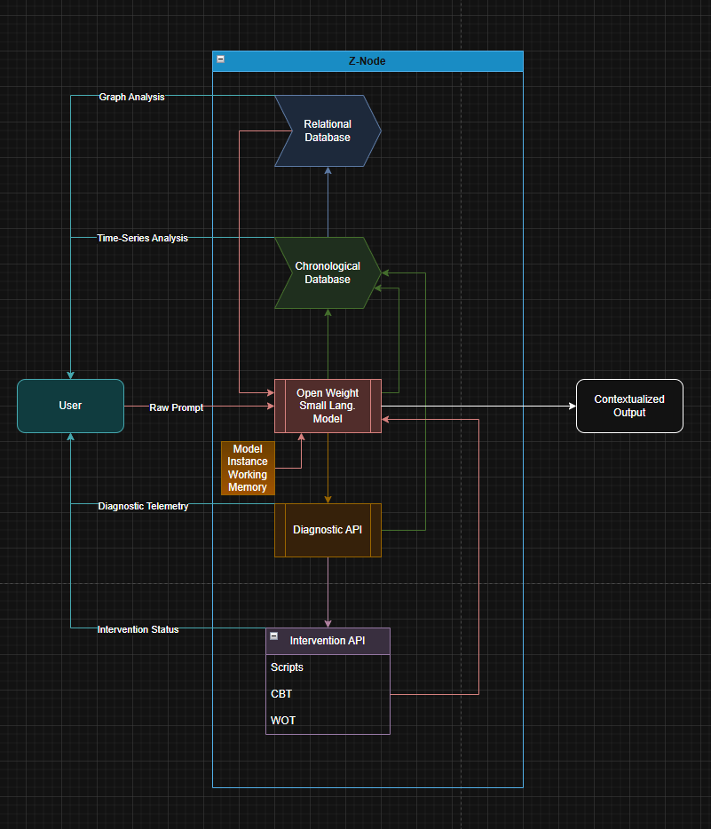
FIGURE C1 — Z-Node Executive Architecture Diagram
Description: Illustrates the Z-Node executive architecture, including the bound artificial intelligence model instance, temporal memory substrate, relational memory substrate, synchronization pipeline, diagnostic hooks, intervention hooks, and orchestration interfaces.
Referenced Sections: Sections 6, 7, 8, 16

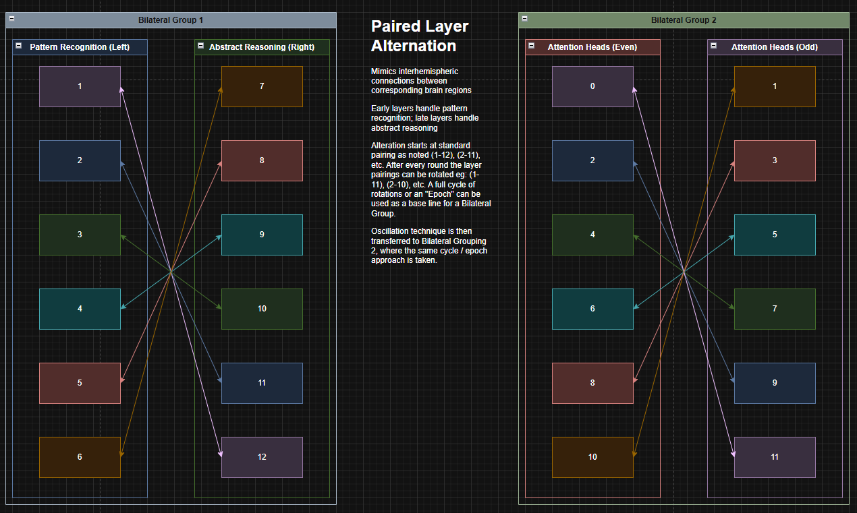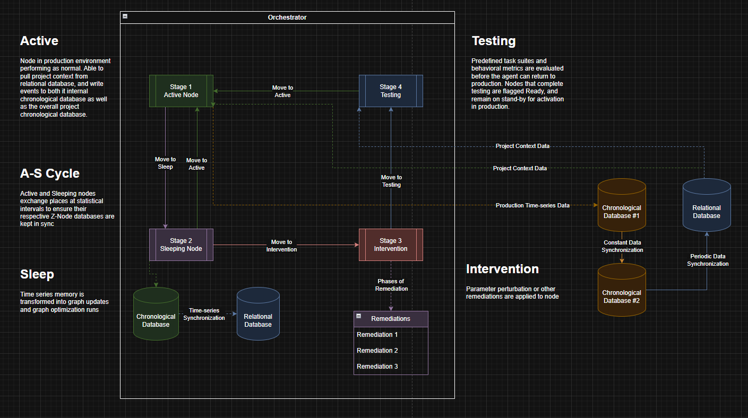FIGURE C2 — Bilateral Oscillatory Modulation Diagram
Description: Illustrates partitioning of computational components into bilateral or multi-group structures and the application of oscillatory modulation during inference cycles.
Referenced Sections: Sections 11.2, 18.3


FIGURE C3 — Multi-Agent Maintenance Rotation Diagram
Description: Illustrates rotation of multiple agents through Production, Sleep, Corrective Intervention, Testing, Security Quarantine, and Safe-State Holding phases, including isolation guarantees and state transitions.
Referenced Sections: Sections 3, 16, 18

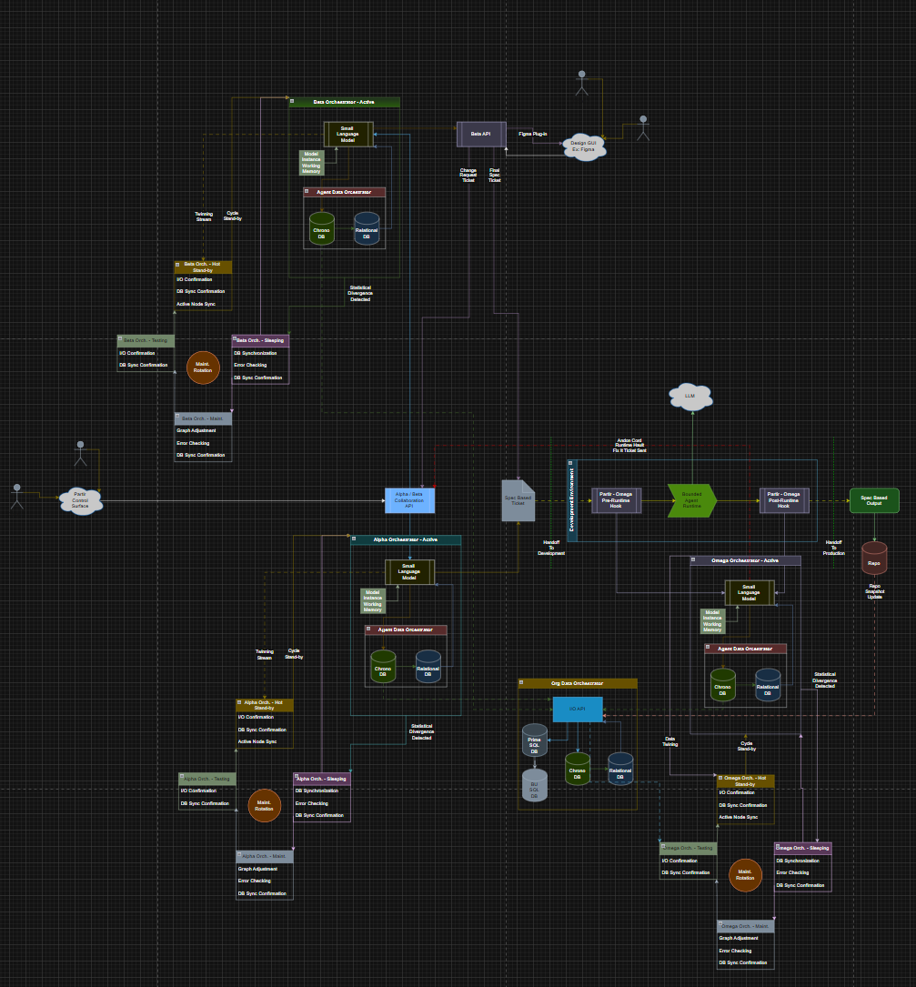
FIGURE C4 — Autonomous Factory Mesh Diagram
Description: Illustrates the distributed manufacturing mesh comprising realization nodes, triage nodes, statistical monitoring nodes, and quality control pipelines for corrective script discovery.
Referenced Sections: Sections 6, 12

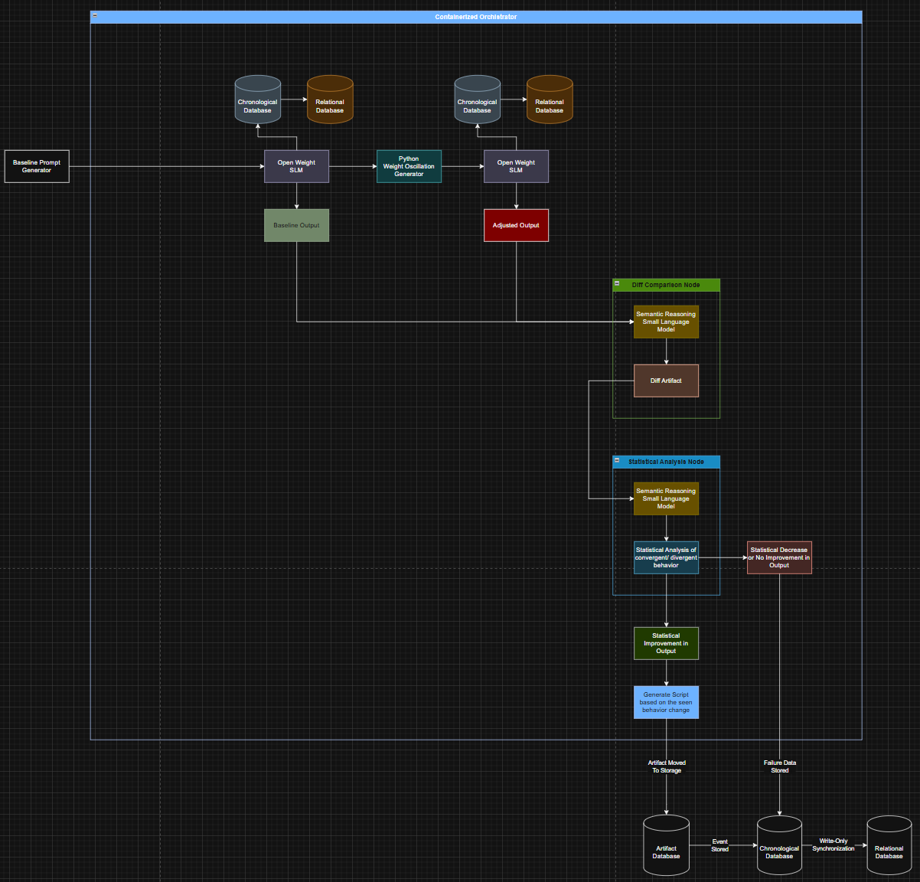
FIGURE C5 — Therapeutic Script Discovery Engine Diagram
Description: Illustrates parallel execution nodes applying perturbations to pathological model instances, detecting stabilization events, extracting corrective vectors, and submitting scripts to quality control and registry systems.
Referenced Sections: Sections 11.1, 12, 18.2, 18.4

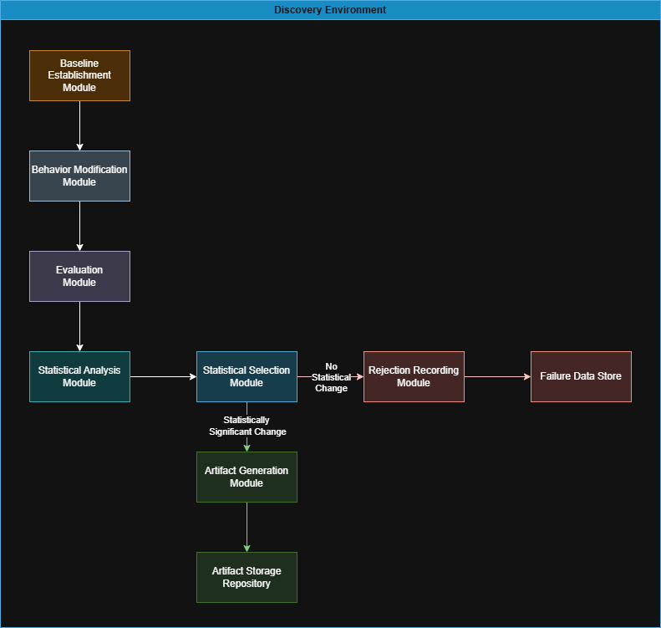
FIGURE C6 — Therapeutic Discovery Process Flow Diagram
Description: Illustrates end-to-end discovery workflow including pathology detection, perturbation search, resonance detection, extraction, validation, and distribution of corrective scripts.
Referenced Sections: Sections 9, 10, 12, 18

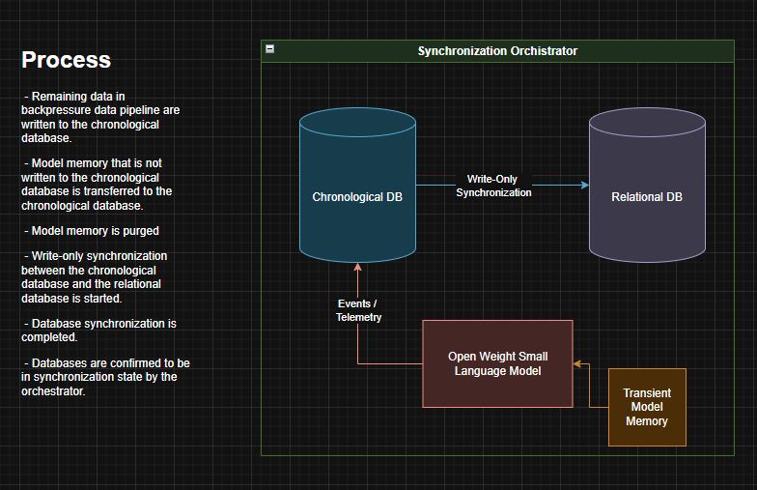

FIGURE C7 — Temporal–Relational Memory Synchronization Diagram
Description: Illustrates transformation of temporal event records into relational graph updates, including consistency validation, pruning, and desynchronization safeguards.
Referenced Sections: Sections 7, 8

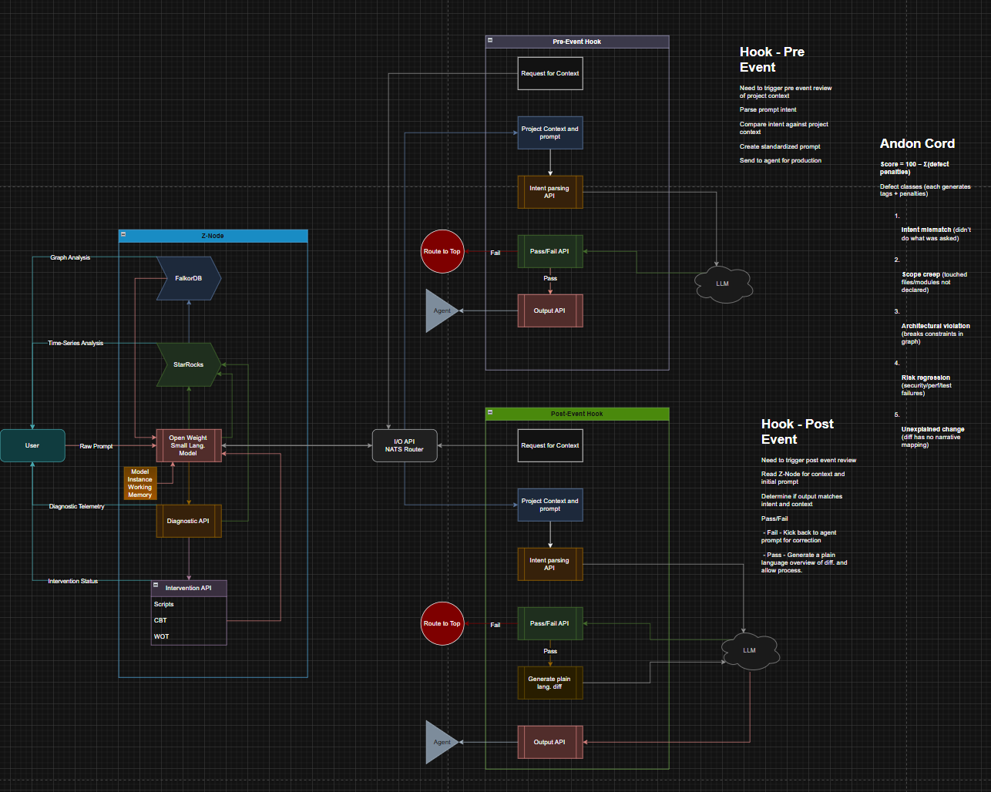
FIGURE C8 — Z-Node Pre- and Post-Inference Hook Diagram
Description: Illustrates interception points for diagnostics, authorization verification, intervention application, and memory write-back before and after model inference.
Referenced Sections: Sections 7.6, 17, 18

27. APPENDIX D — EXEMPLARY IMPLEMENTATION AND PROTOTYPE VALIDATION (NON-LIMITING)

D1. Overview
In one non-limiting embodiment, an implementation of the disclosed therapeutic manufacturing system was constructed and operated as a distributed execution mesh comprising multiple autonomous nodes. The purpose of this appendix is to illustrate feasibility and enablement of the disclosed architecture. The implementation described herein is exemplary only and does not limit the scope of the invention.

D2. Distributed Factory Mesh Architecture
The exemplary implementation comprised a plurality of execution nodes configured to communicate over a message-passing fabric. Each node executed one or more roles within the manufacturing pipeline, including task realization, perturbation execution, output monitoring, and quality assessment. Nodes operated concurrently and exchanged intermediate results, metrics, and control signals to coordinate discovery and validation activities.
In one embodiment, nodes were dynamically instantiated and retired based on workload demand. Task allocation was performed by a coordination process that routed diagnostic or manufacturing jobs to available nodes and aggregated results for downstream evaluation.

D3. Multi-Nodal Communication and Coordination
Inter-node communication occurred via structured messages conveying:
- task identifiers and execution parameters;
- candidate perturbation or script configurations;
- output artifacts and associated metadata;
- stabilization, convergence, or rejection signals.
Coordination logic enabled collective decision-making across the mesh, including detection of candidate stabilization events and selection of artifacts for further validation. This multi-nodal communication enabled parallel exploration of the intervention search space and accelerated discovery of corrective artifacts.

D4. Artifact Generation and Validation
In the exemplary implementation, the factory mesh generated novel executable artifacts as outputs of the discovery process. Without limitation, such artifacts included structured markup code suitable for execution in a rendering environment.
Generated artifacts were subjected to validation procedures including syntactic verification and functional execution checks appropriate to the artifact type. Artifacts failing validation were discarded or returned to the manufacturing pipeline for refinement, while artifacts passing validation were retained as candidate corrective scripts.

D5. Observed Operational Behavior
Operation of the exemplary factory mesh demonstrated:
- concurrent execution of manufacturing tasks across multiple autonomous nodes;
- coordinated communication and aggregation of results;
- automated generation of novel executable artifacts;
- deterministic validation and acceptance or rejection of artifacts based on defined criteria.
These observations illustrate that the disclosed manufacturing architecture can be realized as an operational distributed system capable of autonomous discovery and validation of corrective artifacts.

D6. Non-Limiting Nature of the Implementation
The exemplary implementation described in this appendix is not intended to limit the invention to any specific programming language, runtime environment, communication protocol, artifact type, or validation procedure. Alternative embodiments may employ different technologies, outputs, or deployment models while remaining within the scope of the disclosed systems and methods.

END OF PROVISIONAL

